School Administrative Unit #31
Newmarket School District
186A Main Street, Newmarket, NH 03857
(603) 659-5020 Fax (603) 659-5022
www.newmarket.k12.nh.us

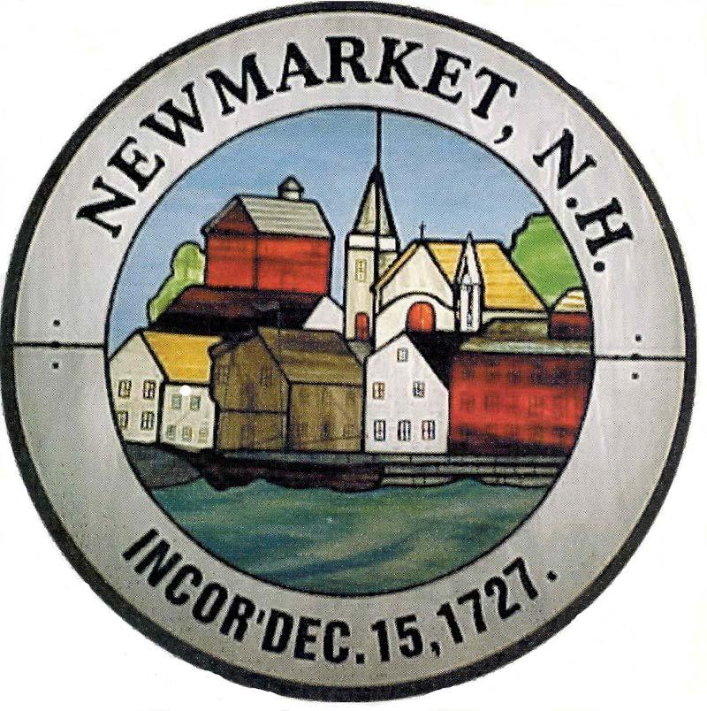

Todd Allen Patricia Wons
Superintendent of Schools Director of CIA &,
Professional Learning

Janna Mellon Erica MacNeil
Business Administrator Director of Student Services
SCHOOL YEAR 2023-2024
FREQUENTLY ASKED QUESTIONS ABOUT FREE AND REDUCED-PRICE SCHOOL MEALS
Dear Parent/Guardian:
Children need healthy meals to learn. Newmarket School District offers healthy meals every school day. Breakfast costs $1.75 at NES and $2.00 at NJSHS; lunch costs $3.25 at NES and $3.50 at NJSHS. Your children may qualify for free meals or for reduced price meals. Reduced price is $0.00 for breakfast and $0.40 for lunch. This packet includes an application for free or reduced price meal benefits, and a set of detailed instructions. Below are some common questions and answers to help you with the application process.
- Who can get free or reduced priced meals?
  - All children in households receiving benefits from [State SNAP], [the Food Distribution Program on Indian Reservations (FDPIR)] or [State TANF], are eligible for free meals.
  - Foster children that are under the legal responsibility of a foster care agency or court are eligible for free meals.
  - Children participating in their school’s Head Start program are eligible for free meals.
  - Children who meet the definition of homeless, runaway, or migrant are eligible for free meals.
  - Children may receive free or reduced price meals if your household’s income is within the limits on the Federal Income Eligibility Guidelines. Your children may qualify for free or reduced price meals if your household income falls at or below the limits on this chart.

FEDERAL ELIGIBILITY INCOME CHART For School Year 2023-2024
Household size | Yearly | Monthly | Weekly
1 | $ 26,973 | $ 2,248 | $ 519
2 | $ 36,482 | $ 3,041 | $ 702
3 | $ 45,991 | $ 3,833 | $ 885
4 | $ 55,500 | $ 4,625 | $ 1,068
5 | $ 65,009 | $ 5,418 | $ 1,251
6 | $ 74,518 | $ 6,210 | $ 1,434
7 | $ 84,027 | $ 7,003 | $ 1,616
8 | $ 93,536 | $ 7,795 | $ 1,799
Each additional person: | + $ 9,509 | + $ 793 | + $ 183

- HOW DO I KNOW IF MY CHILDREN QUALIFY AS HOMELESS, MIGRANT, OR RUNAWAY? Do the members of your household lack a permanent address? Are you staying together in a shelter, hotel, or other temporary housing arrangement? Does your family relocate on a seasonal basis? Are any children living with you who have chosen to leave their prior family or household? If you believe children in your household meet these descriptions and haven’t been told your children will get free meals, please call or email [school, homeless liaison or migrant coordinator].
- DO I NEED TO FILL OUT AN APPLICATION FOR EACH CHILD? No. Use one Free and Reduced Price School Meals Application for all students in your household. We cannot approve an application that is not complete, so be sure to fill out all required information. Return the completed application to: Newmarket School District, Attn: Justin Loring, 186A Main Street, Newmarket, NH 03857.
- SHOULD I FILL OUT AN APPLICATION IF I RECEIVED A LETTER THIS SCHOOL YEAR SAYING MY CHILDREN ARE ALREADY APPROVED FOR FREE MEALS? No, but please read the letter you got carefully and follow the instructions. If any children in your household were missing from your eligibility notification, contact Justin Loring at 603-569-5020, loringj@newmarket.k12.nh.us, immediately.
- CAN I APPLY ONLINE? Yes! You are encouraged to complete an online application instead of a paper application if you are able. The online application has the same requirements and will ask you for the same information as the paper application. Visit newmarket.k12.nh.us, under the Food Service Tab to begin or to learn more about the online application process. Contact Justin Loring at 603-659-5020, loringj@newmarket.k12.nh.us, if you have any questions about the online application.
- MY CHILD’S APPLICATION WAS APPROVED LAST YEAR. DO I NEED TO FILL OUT A NEW ONE? Yes. Your child’s application is only good for that school year and for the first few days of this school year, through October 10, 2023. You must send in a new application unless the school told you that your child is eligible for the new school year. If you do not send in a new application that is approved by the school or you have not been notified that your child is eligible for free meals, your child will be charged the full price for meals.
- I GET WIC. CAN MY CHILDREN GET FREE MEALS? Children in households participating in WIC may be eligible for free or reduced price meals. Please send in an application.
- Will the information I give be checked? Yes. We may also ask you to send written proof of the household income you report.
- If I don’t qualify now, may I apply later? Yes, you may apply at any time during the school year. For example, children with a parent or guardian who becomes unemployed may become eligible for free and reduced price meals if the household income drops below the income limit.
- What if I disagree with the school’s decision about my application? You should talk to school officials. You also may ask for a hearing by calling or writing to: Janna Mellon, 603-659-5020, mellonj@newmarket.k12.nh.us.
- May I apply if someone in my household is not a U.S. citizen? Yes. You, your children, or other household members do not have to be U.S. citizens to apply for free or reduced price meals.
- What if my income is not always the same? List the amount that you normally receive. For example, if you normally make $1000 each month, but you missed some work last month and only made $900, put down that you made $1000 per month. If you normally get overtime, include it, but do not include it if you only work overtime sometimes. If you have lost a job or had your hours or wages reduced, use your current income.
- WHAT IF SOME HOUSEHOLD MEMBERS HAVE NO INCOME TO REPORT? Household members may not receive some types of income we ask you to report on the application, or may not receive income at all. Whenever this happens, please write a 0 in the field. However, if any income fields are left empty or blank, those will also be counted as zeroes. Please be careful when leaving income fields blank, as we will assume you meant to do so.
- We are in the military. Do we REPORT OUR INCOME DIFFERENTLY? Your basic pay and cash bonuses must be reported as income. If you get any cash value allowances for off-base housing, food, or clothing, it must also be included as income. However, if your housing is part of the Military Housing Privatization Initiative, do not include your housing allowance as income. Any additional combat pay resulting from deployment is also excluded from income.
- WHAT IF THERE ISN’T ENOUGH SPACE ON THE APPLICATION FOR MY FAMILY? List any additional household members on a separate piece of paper, and attach it to your application. Contact Justin Loring at 603-659-5020, loringj@newmarket.k12.nh.us to receive a second application.
- My family needs more help. Are there other programs we might apply for? To find out how to apply for SNAP, TANF or FDPIR or other assistance benefits, contact your local assistance office or call client services toll free at 1-800-852-3345 ext. x4238, 1-844-275-3447 or 1-603-271-9700.
If you have other questions or need help, call [phone number].
Sincerely,

Janna Mellon, Business Administrator
This institution is an equal opportunity provider.

